Name: Pranali Sonawane
Subject: CCNA
Date: 13-11-2025
Lab – EIGRP Configuration :
First Take 3 Routers (Ex: 1841), 3 Switches And 6 Pc’s, Connect Routers, Switches And Pc’s Using Straight Through Cables.
Telnet Config: 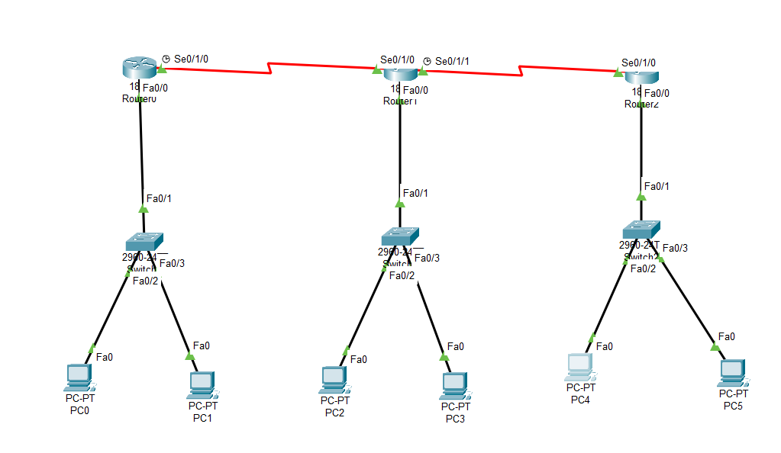

Open Router 0 – CLI prompt then type following commands
Router>enable
Router#configure terminal
Router(config)# hostname R1
R1(config)# interface fastEthernet 0/0
R1(config-if)# ip address 10.0.0.1 255.0.0.0
R1(config-if)#no shutdown
R1(config-if)#ip dhcp pool DHCP
R1(dhcp-config)# network 10.0.0.0 255.0.0.0
R1(dhcp-config)#default-router 10.0.0.1
R1(dhcp-config)#exit
R1(config)#interface serial 0/1/0
R1(config-if)#ip address 40.0.0.1 255.0.0.0
R1(config-if)#no shutdown
R1(config-if)#exit
R1(config)#ip route 0.0.0.0 0.0.0.0 40.0.0.2

We have given ip route using default routing to router 0 using command ip route.

Then we configured remote connection using commands:
R1(config)# line vty 0 15
R1(config-line)# password ccna
R1(config-line)# login
R1(config-line)# exit
R1(config)# enable secret ccnp
R1(config)# exit

R1#config t
R1(config)#router eigrp 1
R1(config-router)#network 10.0.0.0 255.0.0.0
R1(config-router)#network 40.0.0.0 255.0.0.0
R1(config-router)#exit
R1(config)#exit
R1#show ip eigrp neighbors
R1#show ip route

Open Router 1 – CLI prompt then type following commands
Router>enable
Router#configure terminal
Router(config)# hostname R2
R2(config)# interface fastEthernet 0/0
R2(config-if)# ip address 20.0.0.1 255.0.0.0
R2(config-if)#no shutdown
R2(config-if)#ip dhcp pool DHCP
R2(dhcp-config)# network 20.0.0.0 255.0.0.0
R2(dhcp-config)#default-router 20.0.0.1
R2(dhcp-config)#exit
R2(config)#interface serial 0/1/0
R2(config-if)#ip address 40.0.0.2 255.0.0.0
R2(config-if)#no shutdown
R2(config)#interface serial 0/1/1
R2(config-if)#ip address 50.0.0.1 255.0.0.0
R2(config-if)#no shutdown
R2(config-if)#exit
R2(config)#ip route 0.0.0.0 0.0.0.0 40.0.0.1
R2(config)#ip route 0.0.0.0 0.0.0.0 50.0.0.2

We have given ip route using default routing to router 0 using command ip route.

Then we configured remote connection using commands:
R2(config)# line vty 0 15
R2(config-line)# password ccna
R2(config-line)# login
R2(config-line)# exit
R2(config)# enable secret ccnp
R2(config)# exit

R2#config t
R2(config)#router eigrp 1
R2(config-router)#network 20.0.0.0 255.0.0.0
R2(config-router)#network 40.0.0.0 255.0.0.0
R2(config-router)#network 50.0.0.0 255.0.0.0
R2(config-router)#exit
R2(config)#exit
R2#show ip eigrp neighbors
R2#show ip route

Open Router 3– CLI prompt then type following commands
Router>enable
Router#configure terminal
Router(config)# hostname R3
R3(config)# interface fastEthernet 0/0
R3(config-if)# ip address 30.0.0.1 255.0.0.0
R3(config-if)#no shutdown
R3(config-if)#ip dhcp pool DHCP
R3(dhcp-config)# network 30.0.0.0 255.0.0.0
R3(dhcp-config)#default-router 30.0.0.1
R3(dhcp-config)#exit
R3(config)#interface serial 0/1/0
R3(config-if)#ip address 50.0.0.2 255.0.0.0
R3(config-if)#no shutdown
R3(config-if)#exit
R3(config)#ip route 0.0.0.0 0.0.0.0 50.0.0.1

We have given ip route using default routing to router 0 using command ip route.

Then we configured remote connection using commands:
R3(config)# line vty 0 15
R3(config-line)# password ccna
R3(config-line)# login
R3(config-line)# exit
R3(config)# enable secret ccnp
R3(config)# exit

R3#config t
R3(config)#router eigrp 1
R3(config-router)#network 30.0.0.0 255.0.0.0
R3(config-router)#network 50.0.0.0 255.0.0.0
R3(config-router)#exit
R3(config)#exit
R3#show ip eigrp neighbors
R3#show ip route

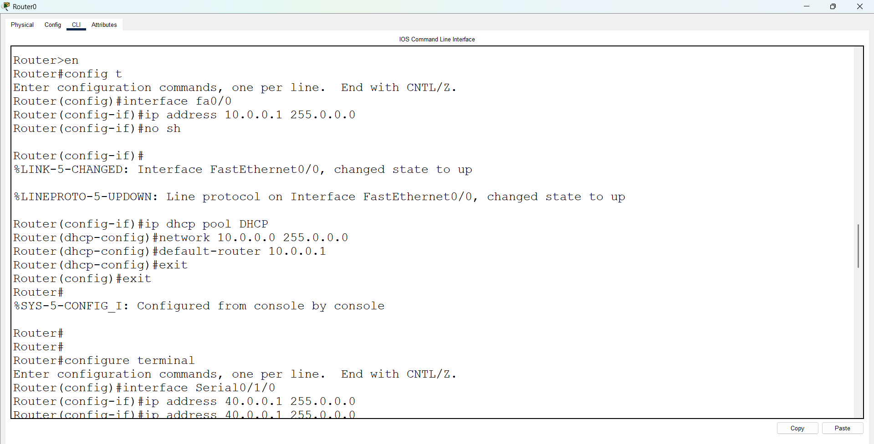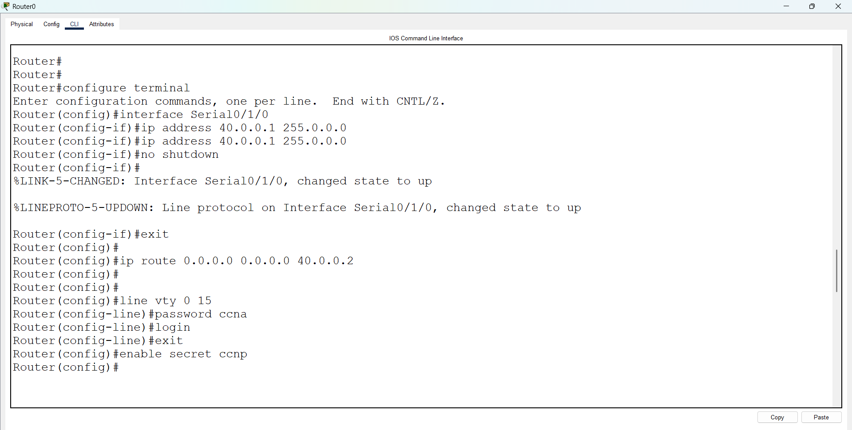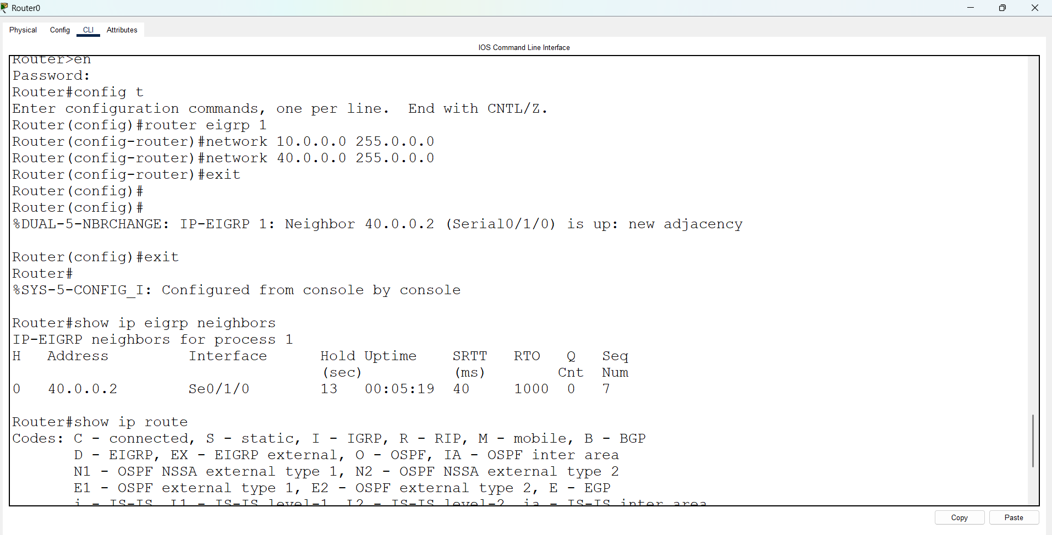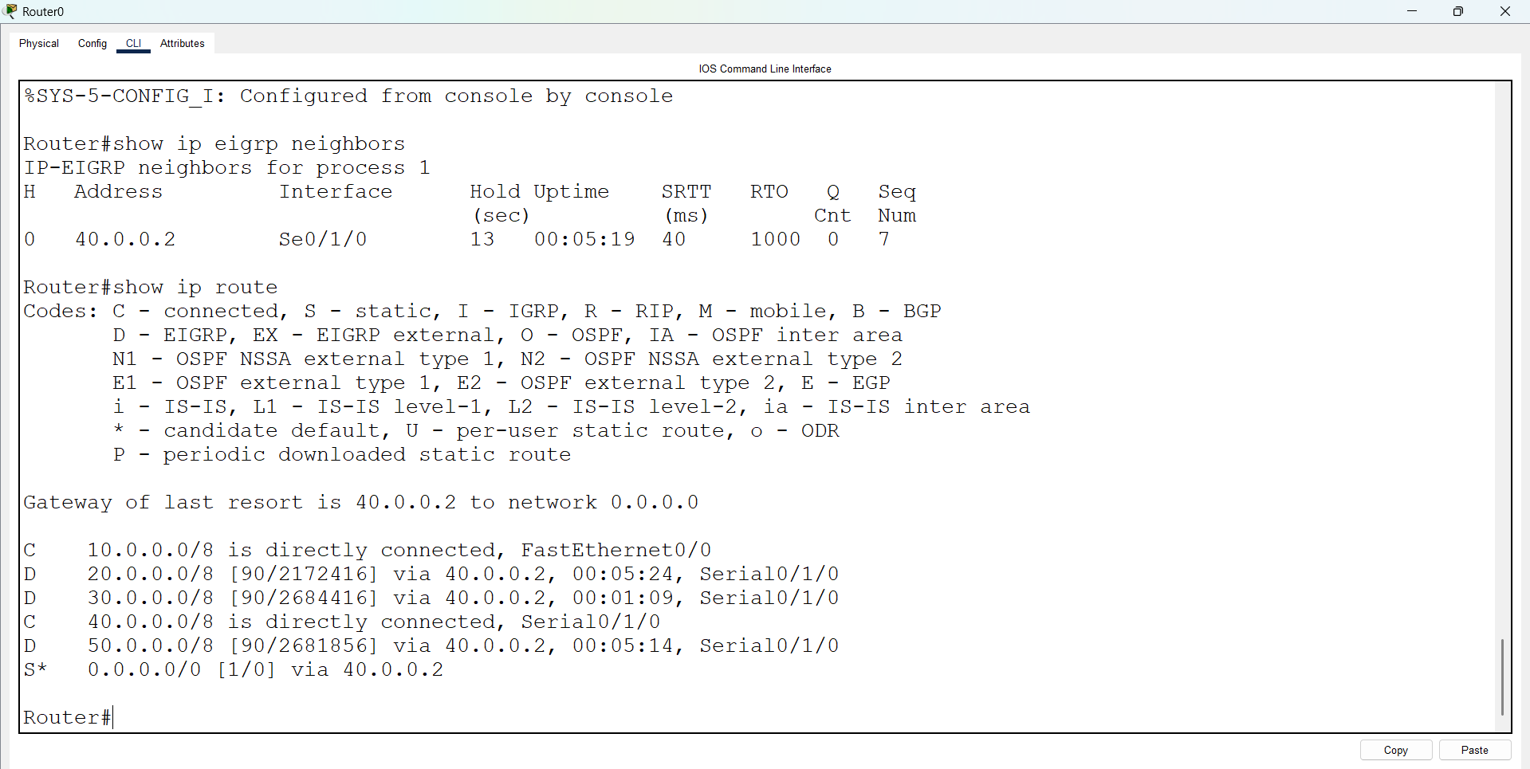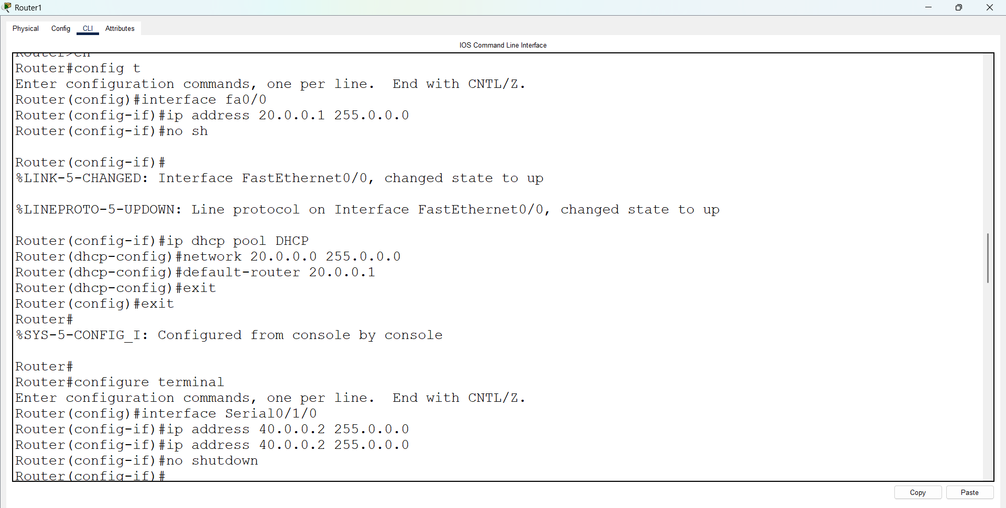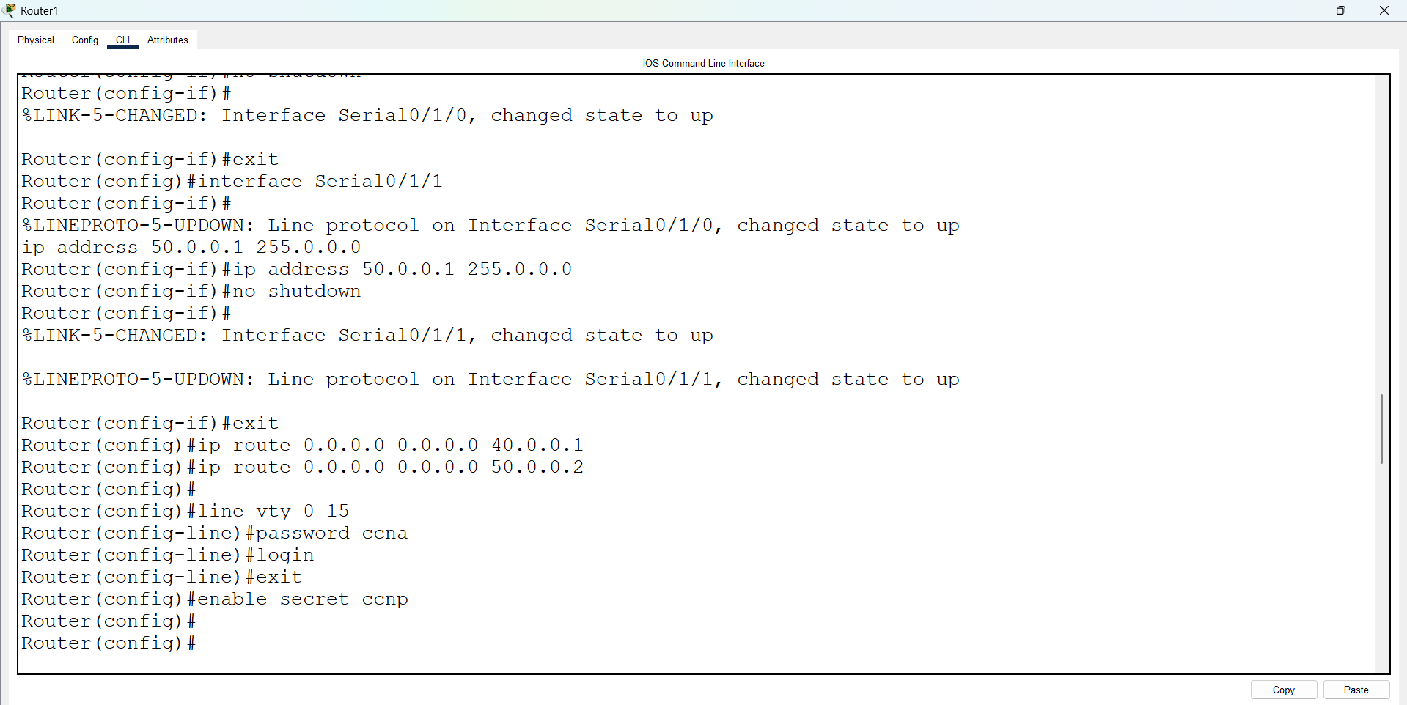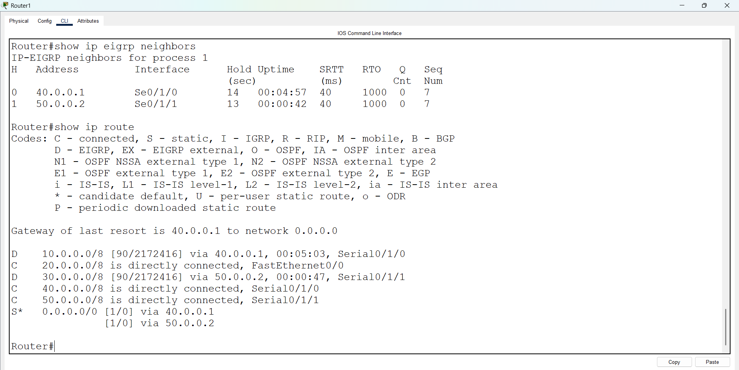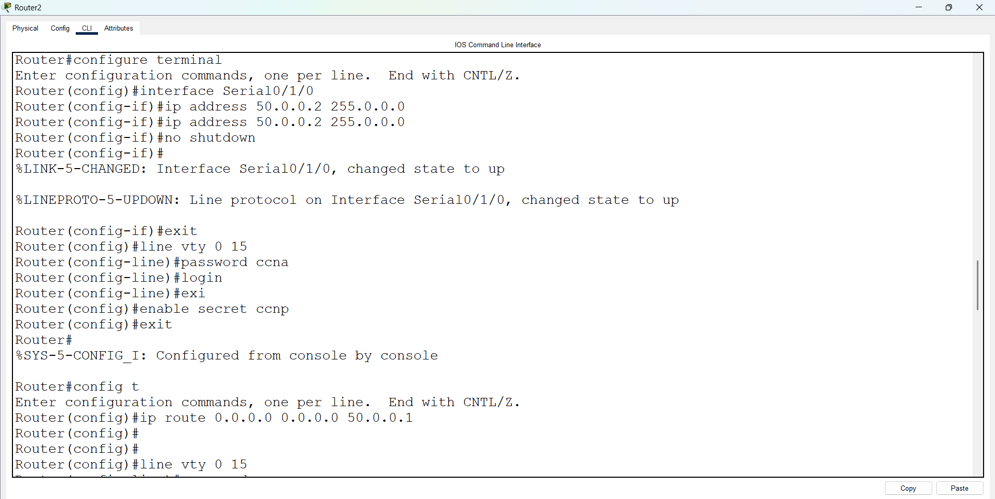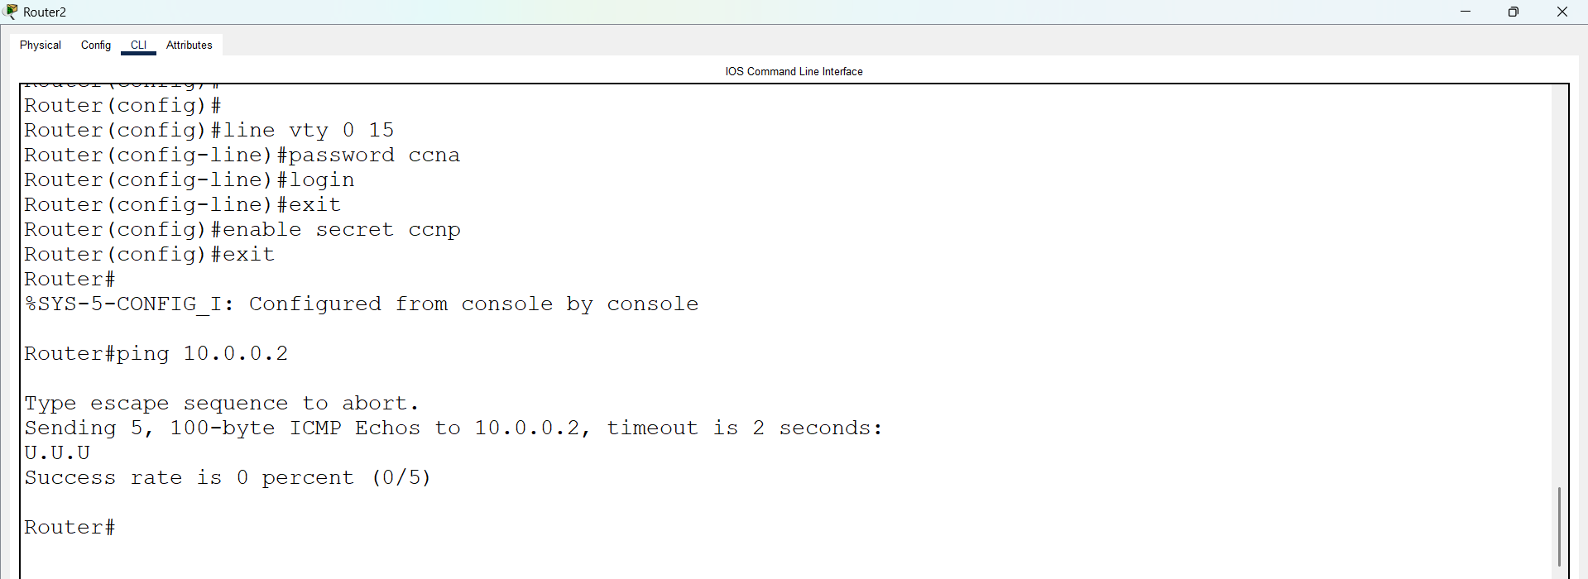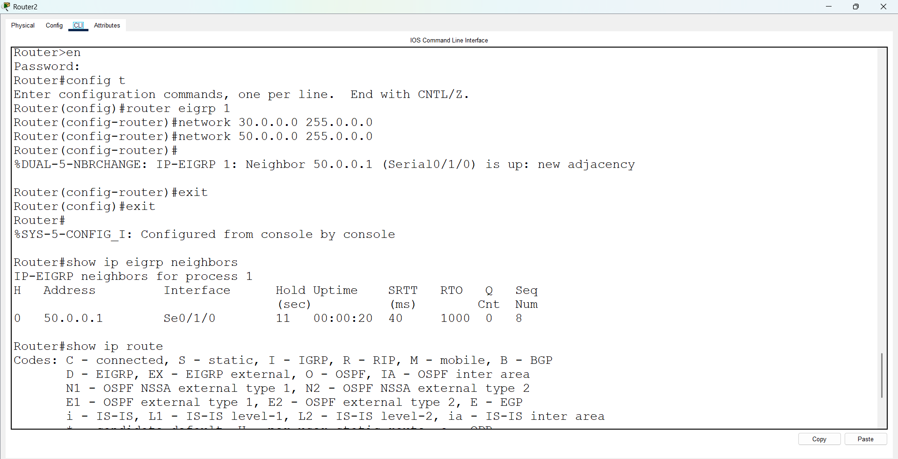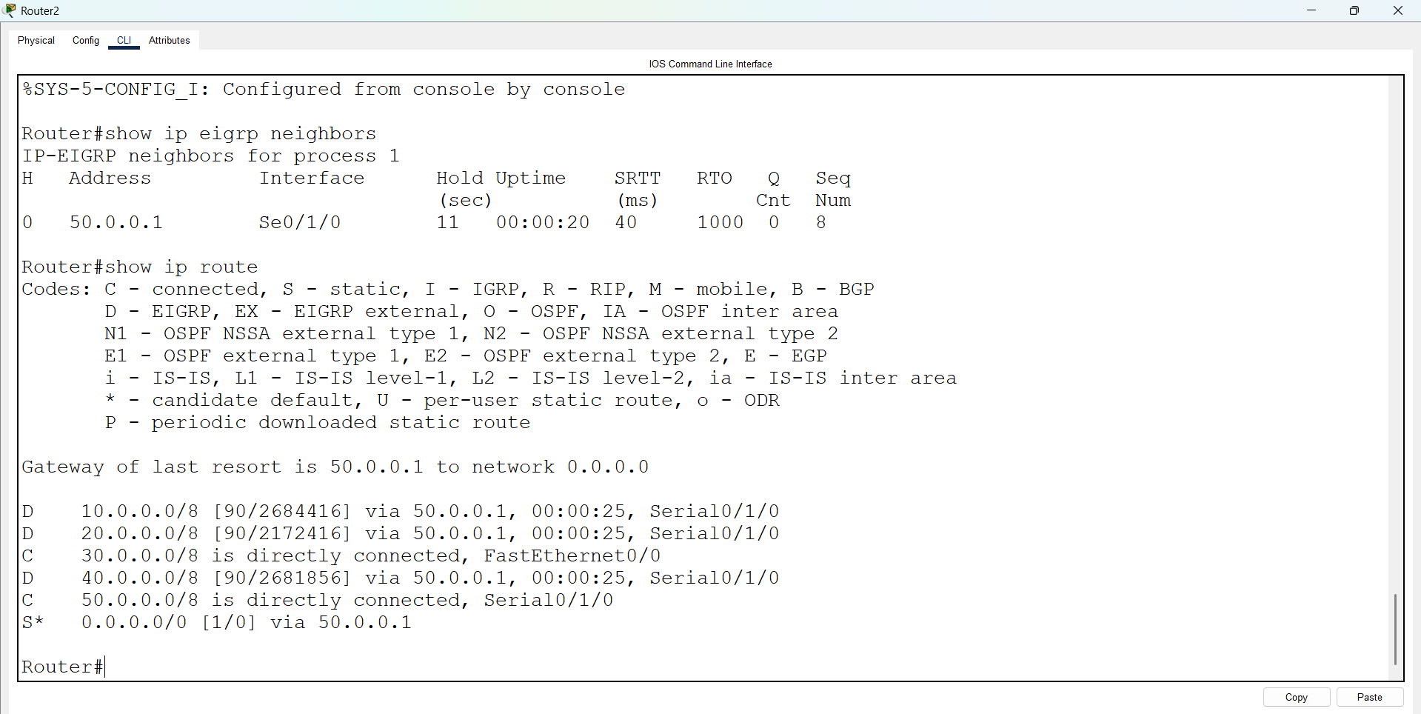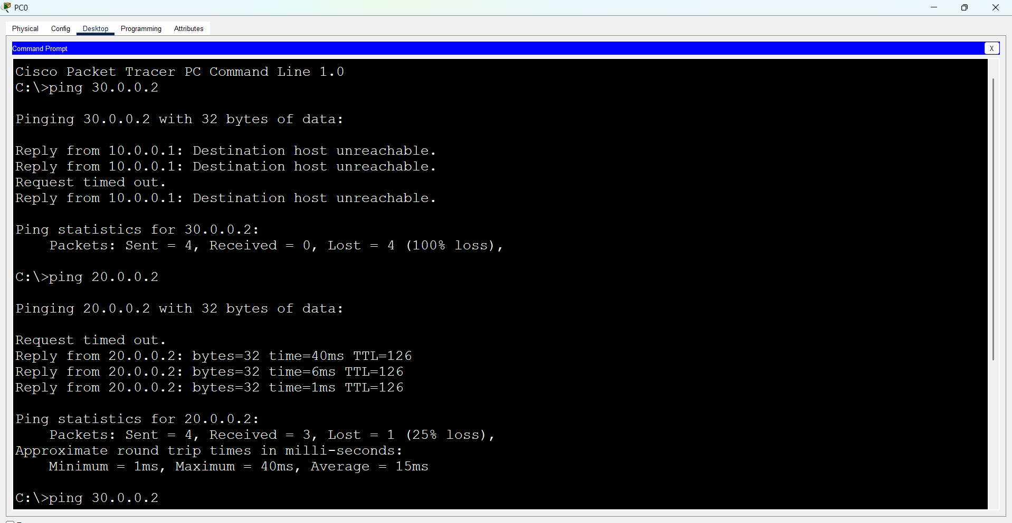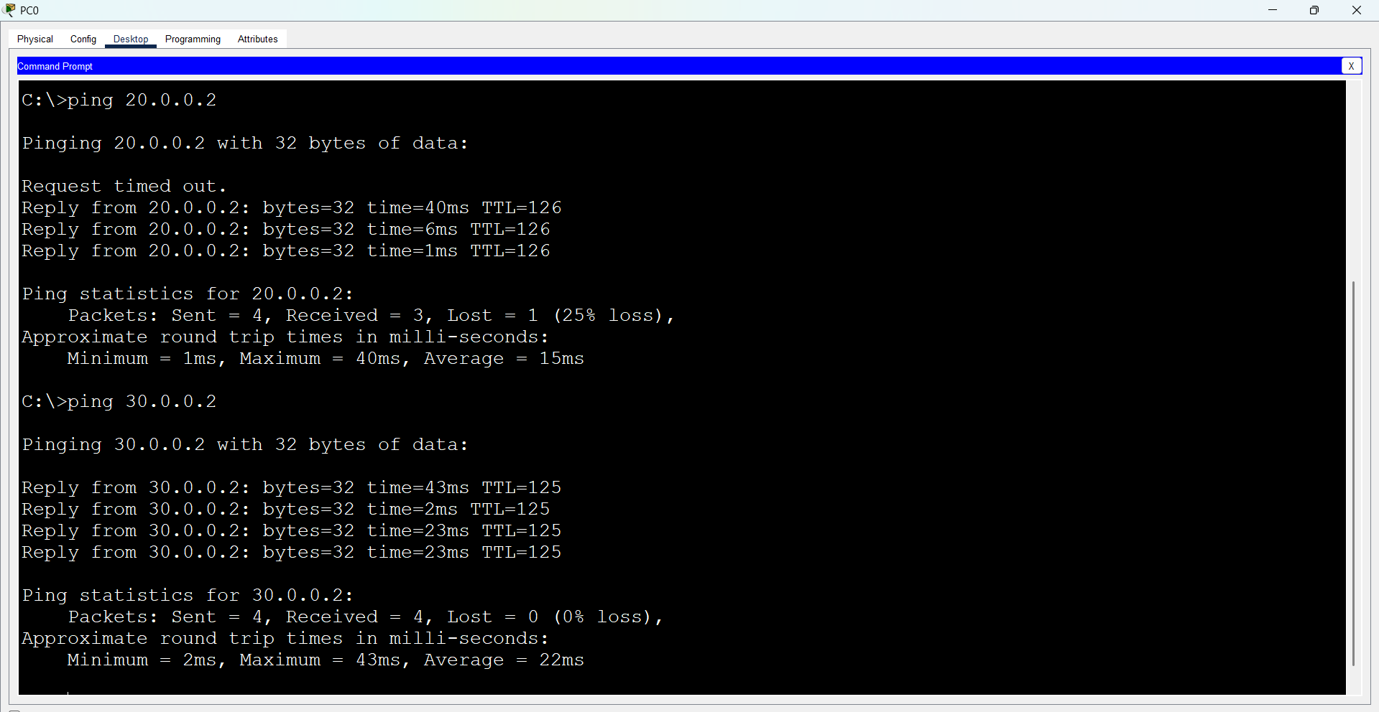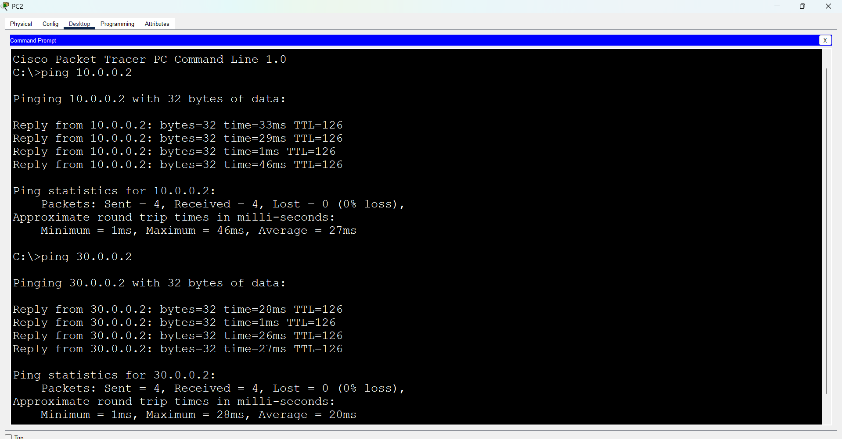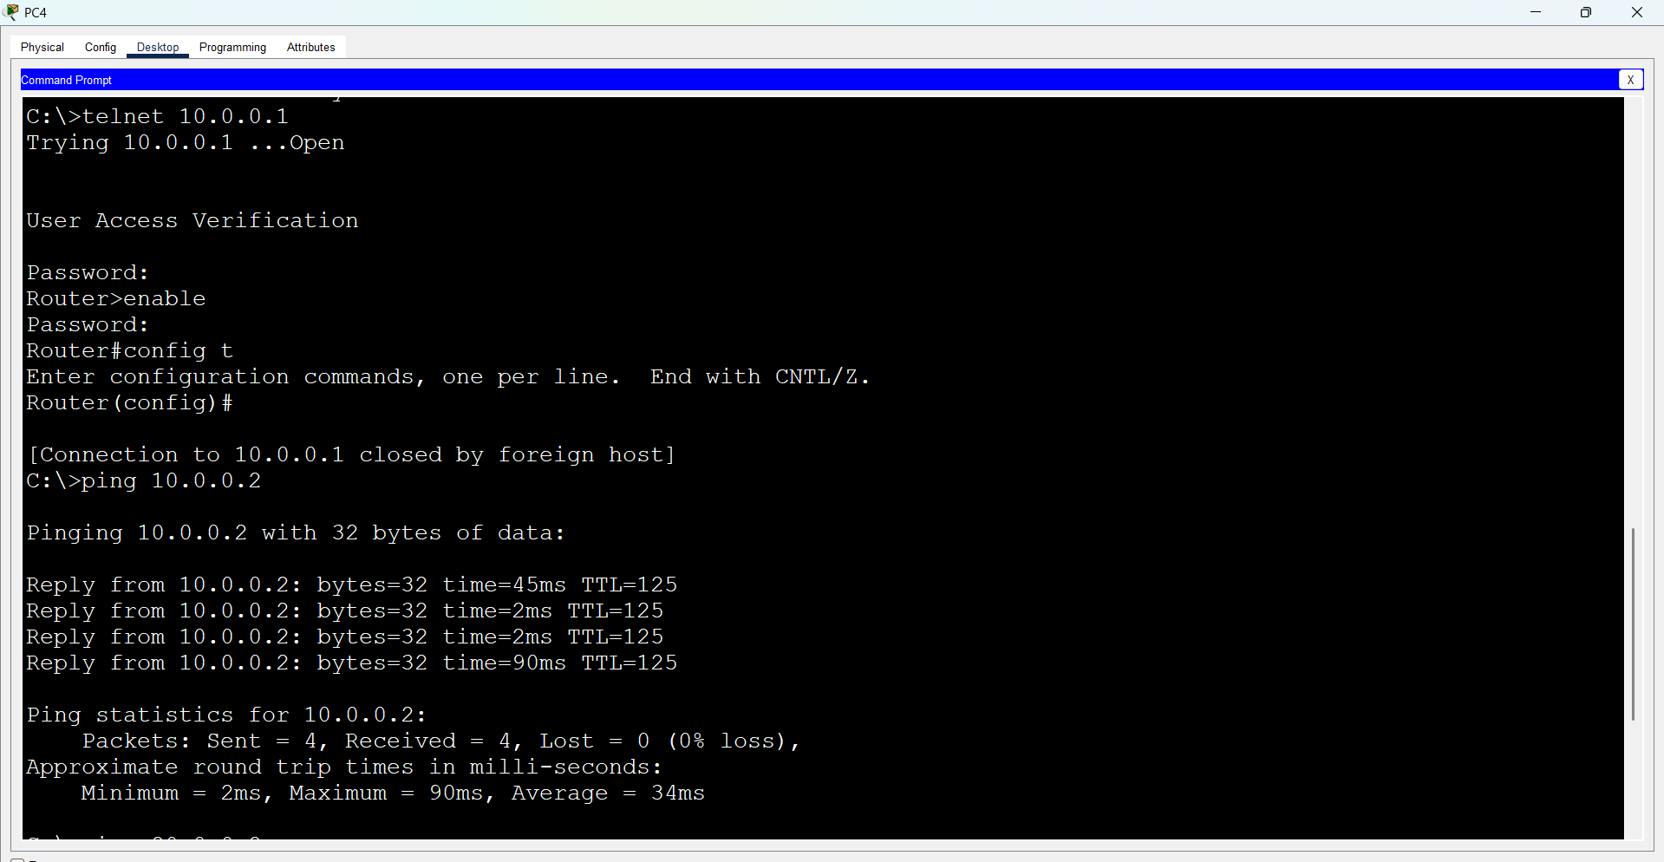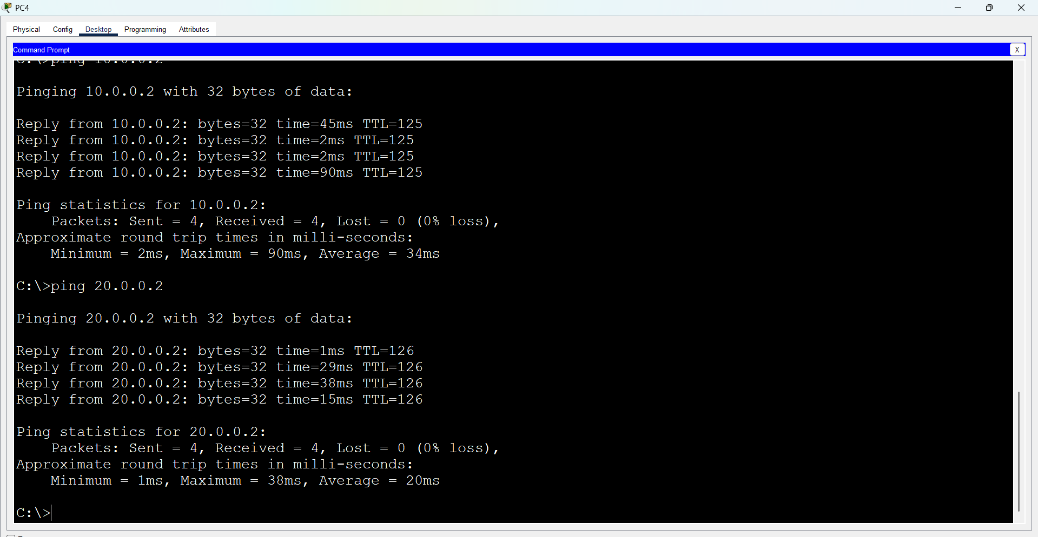

First Take 3 Routers (Ex: 1841), 3 Switches And 6 Pc’s, Connect Routers, Switches And Pc’s Using Straight Through Cables.

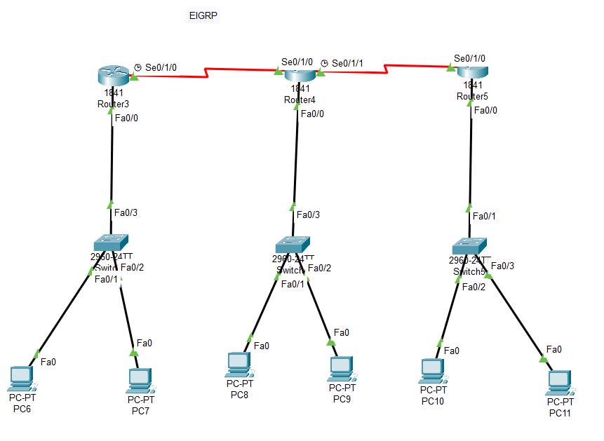
Open Router 0 – CLI prompt then type following commands
Router>enable
Router#configure terminal
Router(config)# interface fastEthernet 0/0
Router(config-if)# ip address 10.0.0.1 255.0.0.0
Router(config-if)#no shutdown
Router(config)#exit

Router(config)#interface serial 0/1/0
Router(config-if)#ip address 40.0.0.1 255.0.0.0
Router(config-if)#no shutdown
Router(config)# exit
Router(config)#router eigrp 1
Router(config-router)#network 10.0.0.0 255.0.0.0
Router(config-router)#network 40.0.0.0 255.0.0.0
Router(config-router)#exit
Router(config)#exit
Router#show ip eigrp neighbors
Router#show ip route

Open Router 1 – CLI prompt then type following commands
Router>enable
Router#configure terminal
Router(config)# interface fastEthernet 0/0
Router(config-if)# ip address 20.0.0.1 255.0.0.0
Router(config-if)#no shutdown
Router(config)#exit

Router(config)#interface serial 0/1/0
Router(config-if)#ip address 40.0.0.2 255.0.0.0
Router(config-if)#no shutdown
Router(config)# exit
Router(config)#router eigrp 1
Router(config-router)#network 20.0.0.0 255.0.0.0
Router(config-router)#network 40.0.0.0 255.0.0.0
Router(config-router)#network 50.0.0.0 255.0.0.0
Router(config-router)#exit
Router(config)#exit
Router#show ip eigrp neighbors
Router#show ip route

Open Router 2 – CLI prompt then type following commands
Router>enable
Router#configure terminal
Router(config)# interface fastEthernet 0/0
Router(config-if)# ip address 30.0.0.1 255.0.0.0
Router(config-if)#no shutdown
Router(config)#exit

Router(config)#interface serial 0/1/1
Router(config-if)#ip address 50.0.0.2 255.0.0.0
Router(config-if)#no shutdown
Router(config)# exit
Router(config)#router eigrp 1
Router(config-router)#network 30.0.0.0 255.0.0.0
Router(config-router)#network 50.0.0.0 255.0.0.0
Router(config-router)#exit
Router(config)#exit
Router#show ip eigrp neighbors
Router#show ip route

